PROCESS REPORT

Students

**Flemming Vindelev – 251398**

**Ionel-Cristinel Putinica – 266123**

**Miruna Botusan – 268013**

**Mihail Rumenov Kenchev – 266106**

Supervisors

**Line Egsgaard – RWD**

**Michael Viuff – SDJ**

**Mona Andersen – SSE**

**21613 Characters**

**ICT Engineering**

**1st Semester**

**17-12-2017**

Table of Content

Group Contract 4

Group Description 6

SWOT Analysis 6

Individual Analysis 6

Group analysis 9

Belbin Profiles 10

Belbin Analysis 12

Flemming Vindelev 12

Ionel-Cristinel Putinica 13

Miruna Botusan 14

Mihail Rumenov Kanchev 15

Considerations and Reflections 17

Considerations before the project 17

Individual Reflections before the Project 18

Cultural Backgrounds 22

Considerations after the project 24

Individual Considerations after the Project 24

Group Work - Issues and Solutions 26

Issue 26

Solution 26

Log 27

Timeline 27

Tasks 28

Flemming Vindelev: 28

Ionut-Cristinel Putinica 28

Miruna Botusan: 28

Mihail Rumenov Kanchev: 28

Leftovers: 29

Supervisor meetings 30

Project Description Presentation - Mona Andersen, Michael Viuff, Henrik Pedersen 30

Requirements and Use Case Diagram Feedback - Michael Viuff 30

Design Class Diagram Feedback - Michael Viuff 31

Supervisor Meeting nr. 1 - Michael Viuff 31

Supervisor Meeting nr. 2 - Mona Andersen 32

Supervisor Meeting nr. 3 - Michael Viuff 32

Supervisor Meeting nr. 4 – Mona Andersen 33

# Group Contract

**Group Name (optional):** Group 1 **Date:** 5/10/2017

These are the terms of group conduct and cooperation that we agree on as a team.

**Participation:** We agree to....

Have every person in the group participate equally.

**Communication:** We agree to...

Give each other feedback and always share our opinions no matter how silly we think they are.

**Meetings:** We agree to....

Have occasional meetings and give each other a heads up if we are late or unable to attend a meeting.

**Conduct:** We agree to....

Respect one another and listen to each other’s opinions.

**Conflict:** We agree to....

Solve our issues by having a mature discussion instead of arguing.

**Deadlines:** We agree to....

Respect all the deadlines and communicate if we encounter any obstacles.

|  |  |  |
| --- | --- | --- |
| **Group Member’s Name** | **Student number** | **Signature** |
| Ionel-Cristinel Putinica | 266123 |  |
| Mihail Kanchev | 266106 |  |
| Miruna Botusan | 268013 |  |
| Flemming Vindelev | 251398 |  |

# Group Description

In this part of the paper the group members are described. It goes into detail about their working habits, strong sides, weak sides as well as their learning styles. This information is used for the members to learn how each other work and create a working pattern which works the best for them.

## SWOT Analysis

SWOT is an analysis model, often used by companies to find potential shared weaknesses and strengths of the employees. SWOT is an acronym and stands for Strengths, Weaknesses, Opportunities and Threats. All group members has filled in the SWOT analysis model, which then has been used to create a single model that represents the group.

### Individual Analysis

In this section we get to see a SWOT analysis on every group member. This went into the thought when they planned their group contract, as well as general working pattern.

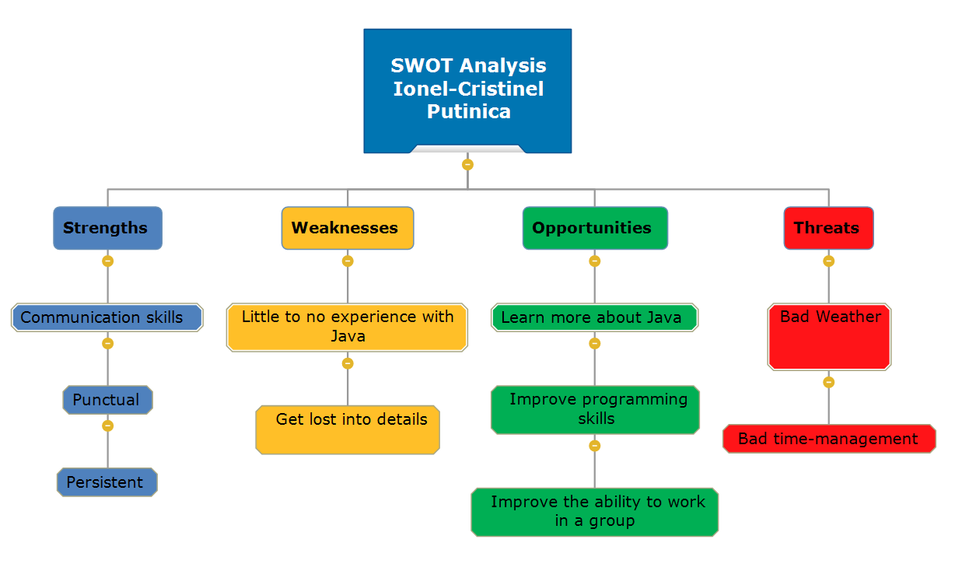

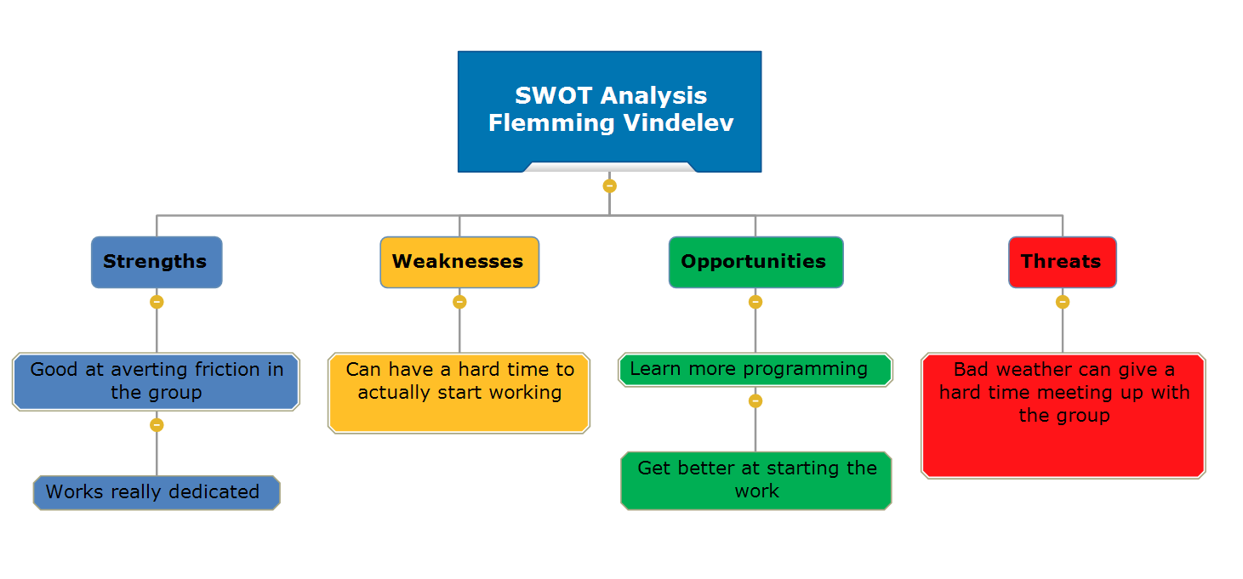

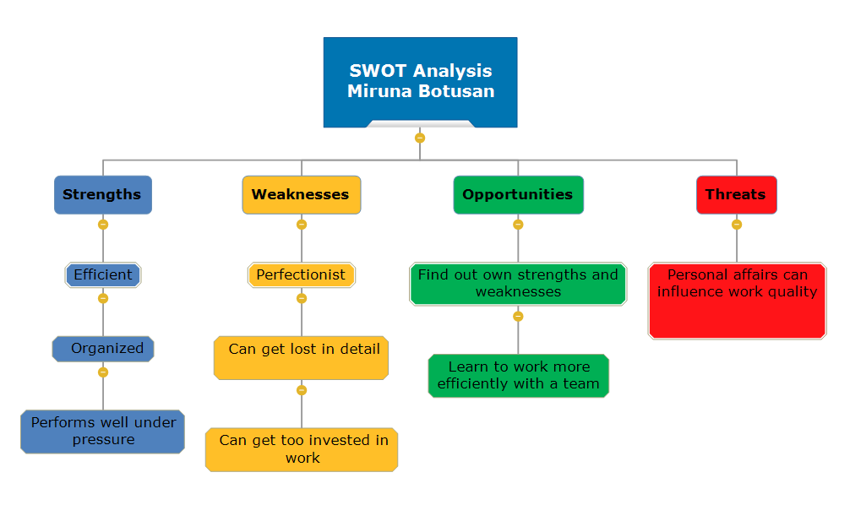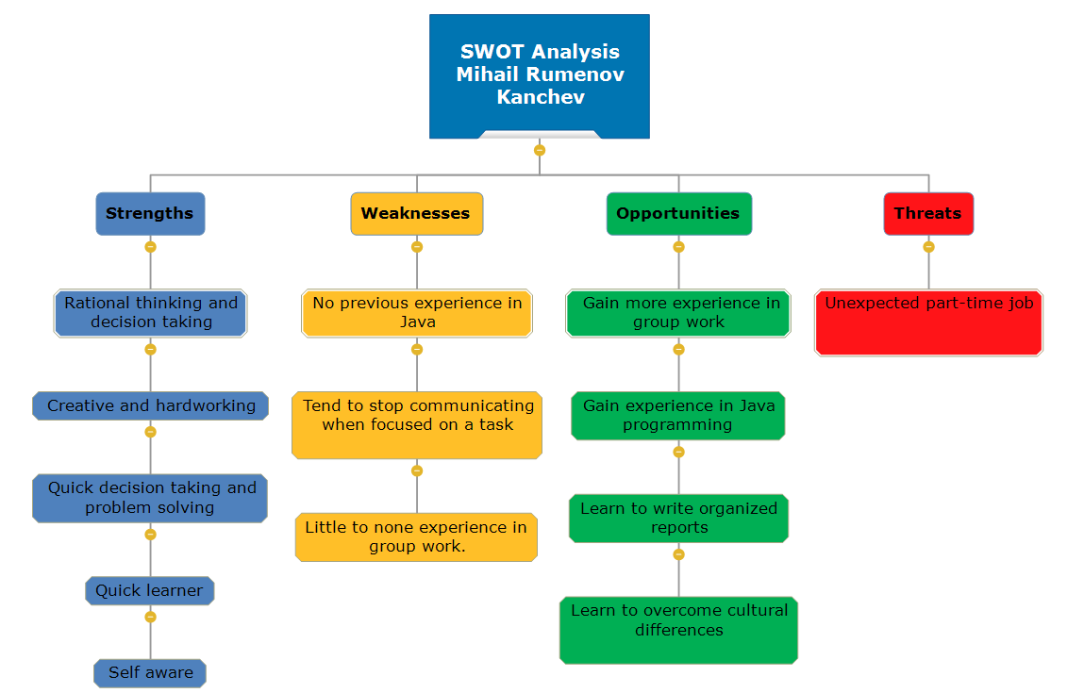

### Group analysis

This is the final SWOT analysis that were made, it represents the group as a whole. And it made the group organize their way of approaching this project.

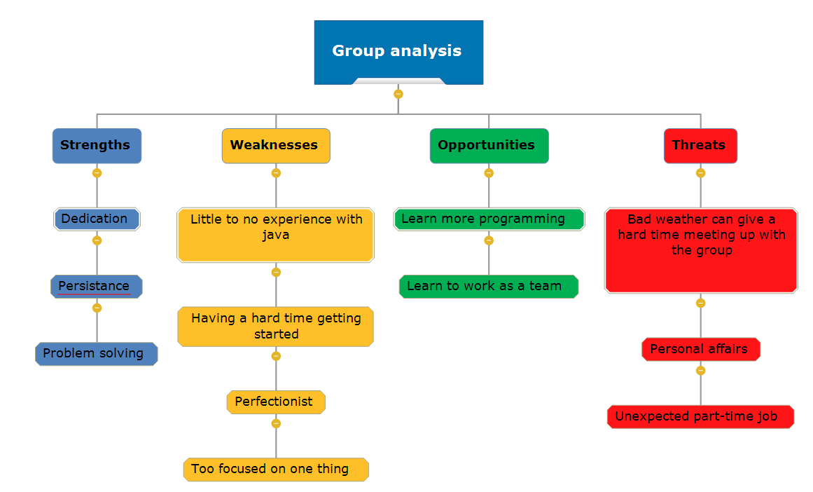

## Belbin Profiles

This section shows Belbin’s team roles applied to each member in the group. Each member have thereafter analyzed their own roles, and how they may affect the group.

Belbin profiles

* **Flemming:** Implementer, Shaper and Team Worker
* **Ionel:** Specialist and Implementer
* **Miruna:** Specialist, Implementer and Shaper
* **Mihail:** Coordinator and Plant

From the profiles above the group has been able to conclude which of the Belbin team roles are present in the group. The following list of roles are in no specific order, and in only there to give an overview.

* **Action oriented:** Shaper and Implementer
* **People oriented:** Team Worker and Coordinator
* **Thought oriented:** Plant and Specialist

As shown above, the group covers all the different groups in the Belbin team roles model. And as shown below the group covers two thirds of all the roles. This means that the group is well balanced.

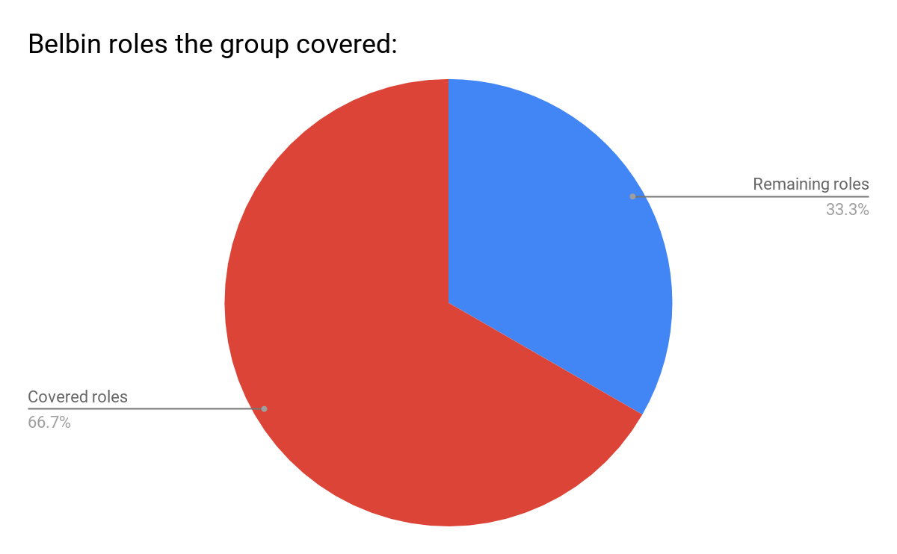

## Belbin Analysis

This section of the paper allows the group members to reflect and analyze their Belbin roles, and how it will affect the group throughout the project. They will account for how well they each think it will go, with the team roles in mind.

### Flemming Vindelev

**Roles:** Implementer, Shaper, Team Worker.

Implementer: I usually like to do things the way i learn them, so whenever someone shows me a new way of doing things, i will have a hard time relearning it.

Shaper: Throughout my life i have had a really hard time working with people, mainly because i am really easy to annoy. Which usually results in me getting aggressive, i have however learned to control my temper a lot more over the time.

Team Worker: We had a few problems as a group, I made sure to listen to what everyone had to say. Whereafter i proposed a solution that made everyone happy.

**Allowable weaknesses:**

As an Implementer I may not want to do things other ways than my own, this can result in arguments about how things should be done in the end.

As a Shaper I get provoked really easily, which means that in combination with Implementer i can be the one who breaks the chain in the group.

As a Team Worker I often want to avoid talking about any problem we might have as a group. Which results in me often working as a lone wolf.

**Strengths and Weaknesses of the group**:

When looking through our roles, I am noticing the fact that we cover a majority of Belbin’s team roles. This means that in theory, we as a group should if we play our cards correctly, be more than able to cover each other’s weaknesses. We also have some of the roles, covered by more than one person. This gives us the opportunity to focus a lot of our effort on specific parts of the project, and really excel at those areas. Seemingly there should not be a weakness which we are not able to overcome as a team. Overall, I would say that we in theory should have a really well working group.

**Conflict or Success:**

If you are able to make a group project without having any problems in the teamwork, you are probably doing something wrong. Problems will always be present, since we all have different backgrounds. This means that we all have our own way of doing things, which results in a lot of compromises having to be made.

### Ionel-Cristinel Putinica

**Roles:** Specialist, Implementer

Specialist: I like to motivate myself and the others and, when working on a project, I always come with an overwhelming amount of ideas.

Implementer: When working on a plan, I carefully thing about a plan, and I prefer following it as much as possible.

**Allowable weaknesses:**

As a specialist, I tend to stick with a straightforward solution, and will often not take into consideration any other solutions than the one I’m used to work with.

As an implementer, it’s hard for me to understand a new solution to a problem.

**Strengths and weaknesses of the group:**

In our group, we have present 6 out of the 9 Belbin Roles, so it is safe to say that our group covers most of the strengths and weaknesses that the Belbin analyses covers. Some of us tend to get lost into details or to be hard to motivate, but the good part is that, because of the diversity of the roles we display, it is an easy task for us to help and complete each other.

**Conflict or success:**

Because of the diversity of team roles we display, we are more likely to have success, and, besides that, even if conflicts will occur, it’s the diversity of team roles that will help us get over this conflicts and solve them.

### Miruna Botusan

**Roles:** Shaper, Implementer, Specialist

Shaper: I have managed to motivate my team to start working on the project, by lightly pressuring them, pushing them in the right direction.

Implementer: I offered to create a work schedule for the group project, in order for all of us to have a plan to follow and not become chaotic and unreliable in our work ethic.

Specialist: I have previous programming knowledge, so I was able to share that extra information with my teammates.

**Allowable weaknesses:**

As a Shaper, I am often on the defensive and could accidentally hurt my teammates in an effort to get them motivated and inspired.

As an Implementer, I can be a bit rigid when plans are changed around, but eventually I can get on board with new ideas.

As a Specialist, I sometimes spend too much time and get lost in the small details.

**Strengths and Weaknesses of the group**:

Looking at our profiles, I noticed that we have a very good set of roles and we are able to complement each other’s lacks more or less. Mihail is our Plant, so he covers the creativity and ideas part, while Flemming and I can motivate the others to get the work done. As Implementers, Ionel and I can lay out plans for the team and Mihail, as a Coordinator, can manage the plan and the team itself. We do have multiple people of the same roles, but that is not necessarily a bad thing, since that way, we can all offer a different input on the same matters.

**Conflicts or Success**:

Conflicts are inevitable in a group, and our group is no exception. I think the fact that we have multiple people within the same role is bound to cause some differences of opinion, but it can definitely be overcome. We have a great role setup which allows us to create a successful project.

### Mihail Rumenov Kanchev

**Roles:** Plant, Co-ordinator.

Co-ordinator: When taking on a challenge, I tend to visualize(by time schedules or graphs) all the goals on the way. I never start a task without having a visual plan of what I need to do.

Plant: When encountering a problem, I tend to think outside the box and solve the problem quickly and efficiently. If a logical problem in my code occurs, I break focus and change my way of thought, which makes finding a solution easier.

**Allowable weaknesses:**

As a Co-ordinator I may encounter some conflicts revolving around the structure and sequence of the group working process.

As a plant when approaching a new problem, I tend to act before thinking it through.

**Strengths and weaknesses of the group:**

The shaper and co-ordinator in our group can combine effort and craft a solid schedule that covers the whole working process. The shaper and plant can motivate the group members and introduce new ideas to the working process. The team worker will help the group with conflict solving and the specialist part of our group brings a much needed knowledge and experience to the working environment. The problem with this composition is all the conflicts that may arise when the specialist’s work approaching gets questioned by the co-ordinator and shapers schedule plan.

**Conflict or success:**

The group Belbin roles are diverse and bring much needed experience and skills to different parts of the project. Problem solving, conflict approaching and personal assignment completion should not be a problem for the group which on its own can predict a successful ending product.

# Considerations and Reflections

In this part of the paper the group explains has written their thoughts about the project, before and after the project began. They have also all reflected on themselves, how they learn and what each of them expect from this project.

## Considerations before the project

The project report has to be written for an audience that is considered to be one that has all the necessary knowledge to understand all the specialized terms, diagrams and tables: the “experts”, therefore, no explanations are required when writing the project report, and the academic writing style has to be used in the redaction.

The main requirements are: all the information and data in the project report have to be stated clearly, using the correct terminology and style, with an emphasis on avoiding slang expressions, the cited sources have to be well grounded. Furthermore, the use of passive voice helps at maintaining the accuracy and formality of the report.

### Individual Reflections before the Project

In this part of the paper we reflect on our Felder profiles, and comments on our own commitment.

#### Flemming Vindelev

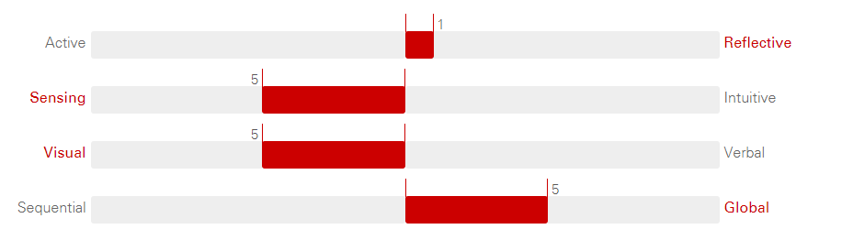**How do I process information?** Reflective

**How do I perceive information?** Sensing

**How do I prefer information being presented?** Visual

**How do I understand information?** Global

**Level of commitment**

* **Hours to spend daily for SEP:** The amount needed, it will vary from day to day. It is something to be discussed as a group.
* **Other commitments in daily personal life:** Nothing
* **Presence throughout semester project weeks:** Full presence
* **Expectations for grade:** I do not expect a certain grade. That being said, my goal is to learn as much as possible.

#### Ionel-Cristinel Putinica

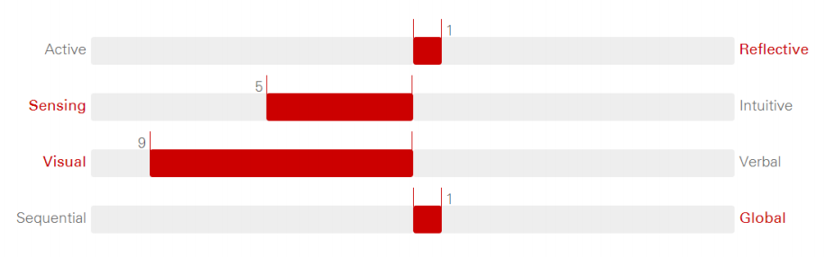

**How do I process information?** Reflective

**How do I perceive information?** Sensing

**How do I prefer information being presented?** Visual

**How do I understand information?** Global

**Level of commitment:**

* **Hours to spend daily for SEP:** As much as needed
* **Other commitments in daily personal life:** No, I have nothing that will prevent me from working on the project and meeting up with the group
* **Presence throughout semester project weeks:** I will stay in Denmark
* **Expectations for grade:** I plan to do things as perfect as possible, so my expectations are for the highest grade.

#### Miruna Botusan

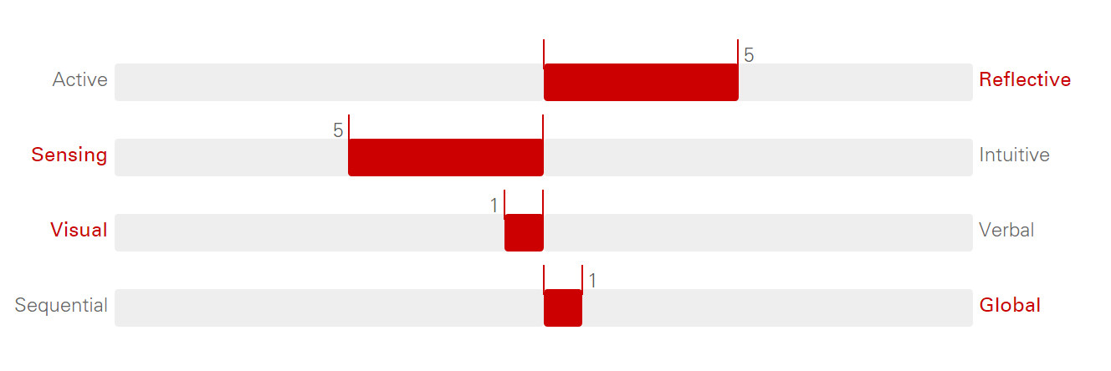

**How do I process information?** Reflective

**How do I perceive information?** Sensing

**How do I prefer information being presented?** Visual

**How do I understand information?** Global

**Level of commitment**

* **Hours to spend daily for SEP:** ~6 hours
* **Other commitments in daily personal life:** No
* **Presence throughout semester project weeks:** Full
* **Expectations for grade:** Best possible grade

#### Mihail Rumenov Kanchev

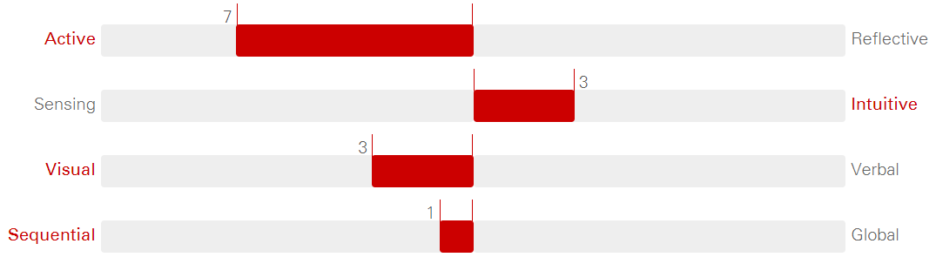

**How do I process information?** Reflective

**How do I perceive information?** Intuitive

**How do I prefer information being presented?** Visual

**How do I understand information?** Sequential

**Level of commitment**

* **Hours to spend daily for SEP:** The whole day (8-14 ours) until the project is considered done.
* **Other commitments in daily personal life:** I do not have any other commitments.
* **Presence throughout semester project weeks:** I will stay in Denmark.
* **Expectations for grade:** I strive for perfection. Highest grade.

### Cultural Backgrounds

**Flemming Vindelev:**

* **High or low context?** LOW CONTEXT
* **Do I communicate directly or indirectly?** DIRECTLY
* **Individualistic or collectivistic?** INDIVIDUALISTIC

Denmark is looked upon as one of the most low context countries in the world, so it would be foolish of me trying to argue against that. And I sure do live up to the reputation, I say things as they are to whoever I am talking to.

**Ionel-Cristinel Putinica:**

* **High or low context?** LOW - HIGH CONTEXT
* **Do I communicate directly or indirectly?** DIRECTLY
* **Individualistic or collectivistic?** COLLECTIVISTIC

Studies show that my country belongs to both low context and high context culture, I tend to agree with these studies, but I tend to find myself belonging to a more to low context culture, because it is easy for me to express my thoughts and I don’t feel uncomfortable saying exactly what I mean.

**Miruna Botusan:**

* **High or low context?** LOW - HIGH CONTEXT
* **Do I communicate directly or indirectly?** DIRECTLY
* **Individualistic or collectivistic?** COLLECTIVISTIC

My culture is placed somewhere in between low and high context, as many studies describe Latin countries. I personally think of it as being low context, because I can easily express myself and communicate all my thoughts with others. I do not think this influences my behavior or my group interaction, as I am naturally a sociable and open-minded person, outside of my culture.

**Mihail Rumenov Kanchev:**

* **High or low context?** HIGH CONTEXT
* **Do i communicate directly or indirectly?**  DIRECTLY
* **Individualistic or collectivistic?** INDIVIDUALISTIC

I communicate directly, honestly and straight to the point. My cultural background, being high-context”, does not influence me in any way.

## Considerations after the project

In this part of the paper, we spend time reflecting on this project as a whole. We each give our own personal reflection, in case there is something a member wants to reflect on, which wouldn’t be a common voice in the group. To round it off, we have made a reflection as a group. This reflection speaks a lot more about the overall process and group work. We have decided to put this group reflection/consideration at the end of the report. Which means it can found under the section called “Summary of SEP1”.

### Individual Considerations after the Project

**Flemming Vindelev:**

Overall the project was really good, i liked working in a group that we choose ourselves. The team work was not flawless though, we had our ups and downs which we had to work around. One of the best things must be getting to know how people work in different cultures. It was really an eye opener but still exciting. If i should complain about something, it would have to have to be the way we learned how to write the project. I felt like we needed someone to say “THIS is how your project should look, and THIS is how you work to get there”. It just felt a bit unorganized and messy. But apart from that, i have learned a lot from this project, and i am looking forward to the next semester.

**Ionel-Cristinel Putinica:**

When I first heard of the semester project from our teachers and the older students, I knew that it will be a challenge, but I only realized how much of a challenge it is when I started working on it with my group. One more thing I realized is that, working on something is 10 times easier when you do it with someone else, and also the result will be 10 times better. SEP1 has improved a lot of my skills: time management, programming skills, writing skills. Working in SEP1 has also given me the ability to work and communicate in an international environment.

**Miruna Botusan:**

At the very beginning of our project, I was very overwhelmed by the workload I knew we would have to get done by the end of the semester. As time went by, my group and I made progress and the project started coming together. I managed to earn my group’s trust and they earned mine, with each day. During the process of putting this project together, I learned that I should give my teammates more credit for their work, and that I should not assign myself as many tasks as possible, because my teammates care about the end product as much as I do, and they can do some of the work themselves.

**Mihail Rumenov Kanchev:**

The confidence plays a huge role in my working process. Before the project week started I was doubting that we can finish everything before the deadline, and be satisfied with the end product at the same time. The project proved me wrong and showed me how much I can do if I focus on my goals. Every complication and challenge was easily solved. Every group goal was completed on time, which ensured calm environment. The project period helped me gain group work experience. It also made me understand how to communicate in a culturally diverse environment. Trusting the group members was hard but they proved me wrong and showed me that if you split the weight amongst the whole group, you might as well have fun while working. I also learned how to structure my questions when asking a supervisor for help. Overall the whole project taught me how to put everything learned through the semester in action.

# Group Work - Issues and Solutions

This section will cover any issues the group may have had, how it affected their work and what they did to solve the issues.

## Issue

Most of the work actually went fluently, all members understood each other, had a similar goal and agreed on how things should be done. However they encountered a problem which started to tear the group apart.

It all came down to personalities and the huge difference between them. A member started doing a lot of work without communicating with the group, so the person went behind the back of the rest of the group. The group also had a member who wanted to do things very organized. Everything should be planned, and nobody did anything without telling the group first. This resulted in a lot of fights, which kind of put the team work on hold.

## Solution

Luckily the group also had a member who were able to talk the others back in a good mood. Then the negotiating started, we had to find a compromise that made everyone happy. We agreed that everyone had something to say, so from now on it was okay to work on something that were not planned, as long as we at least told the group. Afterwards we could always look at it as a group, and change things if change was needed. This made the rest of the project a breeze, our team work were on spot and we started flying through the project.

As a side note this could have all been avoided, if we were more awake in the analysis state. After filling in the SWOT and Belbin analysis, we had everything on paper that could go wrong in front of us. If we had taken a better look back then, this problem would not have occurred.

# Log

In this section of the paper we focus on documenting what was done by who and when it was done. In the section “Timeline” you can see when we started the different parts of the project and when we finished them. And in “Tasks” you can read about who were the “main workers” in the different parts.

## Timeline



## Tasks

### Flemming Vindelev:

* Report Writing
* Testing

### Ionut-Cristinel Putinica

* Report writing
* User guide
* Graphs/Report diagrams

### Miruna Botusan:

* Analysis class diagram
* Design class diagram
* Implementation

### Mihail Rumenov Kanchev:

* Implementation
* Design Class Diagram
* GUI

### Leftovers:

Most people in the group worked on almost everything in the project. However some people went the extra mile in some of the tasks, which is what is noted above in the “Tasks” section. Some of the things not listed, has been listed below. These are the topics we feel like everyone had the same amount of work in.

* Use Case Description
* Use Case Diagram
* Requirements
* Activity Diagram
* Sequence Diagram

# Supervisor meetings

In this section all the meetings the group had with supervisors are described. Some of the meeting were non-scheduled meetings, and took place before the project period. This is why some of them are without a date.

## Project Description Presentation - Mona Andersen, Michael Viuff, Henrik Pedersen

**Hour:** 8.30

**Duration:** 15 minutes

**What we wanted to know:** If our project description lived up to the standards, and learn if there were anything we could improve upon. Whether it comes to formatting or content.

**What we learned:** Overall we did a good job content wise. However, there were some things which belonged in the process report rather than the project description.

**Conclusion:** We took a second look on the project description, were we sorted out the few issues and improved the overall quality.

## Requirements and Use Case Diagram Feedback - Michael Viuff

**What we wanted to know:** We wanted to get feedback on our use case diagram. That includes what was good about it and what was bad, as well as how to improve the things that are bad.

**What we learned:** Our structure was pretty good, no need for major improvement.

**Conclusion:** We ended up fine tuning the diagram. We didn’t want to change up too much, since it was good from the start.

## Design Class Diagram Feedback - Michael Viuff

**What we wanted to know:** We wanted to get feedback on our use case diagram. That includes what was good about it and what was bad, as well as how to improve the things that are bad.

**What we learned:** Our structure was pretty good, no need for major improvement.

**Conclusion:** We ended up fine tuning the diagram. We didn’t want to change up too much, since it was good from the start.

## Supervisor Meeting nr. 1 - Michael Viuff

**Hour:** 10.30

**Duration:** 30 minutes

**We wanted to know:** If activity diagrams should be updated according to the functionality of the system. General feedback on our system this far. How to make sequence diagrams. And lastly how to do javadoc.

**We learned:** We learned that we should update activity diagrams. We got the hang of the process of making a sequence diagram. How to make a javadoc, as well as how much we should include.

**Conclusion:** We went on to update all the diagrams we had currently made. Since they should match the system, and the system does not necessarily end up the way you planned in the beginning.

## Supervisor Meeting nr. 2 - Mona Andersen

**Hour:** 11.50

**Duration:** 10 - 15 minutes

**We wanted to know:** Where to write about issues and solutions in our group/team work. General feedback to see if we were on the right track, when it comes to the process report.

**We learned:** That we should make a new section for group work. We learned that we were on a completely different track when it came to our log.

**Conclusion:** New section for group work were made, to document on issues and solutions we have had in the team work. We also ending up totally rethinking our log, and came up with a new idea.

## Supervisor Meeting nr. 3 - Michael Viuff

**Hour:** 11.00

**Duration:** 30 minutes

**We wanted to know:** How to use Astah for sequence diagrams, since we ran into a problem. We ran into a problem with the javadoc when creating the folder.

**We learned:** We were not thinking correctly in how to do sequence diagrams, so we figured out the correct way. We also learned how to how to get around the issue we had when creating a javadoc folder.

**Conclusion:** We immediately got around to fixing the sequence diagram, while updating all of our other diagrams as well. We noted how to get around the issue we had when creating javadoc.

## Supervisor Meeting nr. 4 – Mona Andersen

**Hour:** 11.25

**Duration:** 30 minutes

**We wanted to know:** If the setup we were currently going with in the reports, was acceptable or if change was needed. Also where to put the appendices.

**We learned:** What to do with appendices, as well as that we should reflect a bit on our cultural background. And lastly that we should document the tasks that had been performed in the project.

**Conclusion:** We quickly began reflecting on our cultural background, where after we made a task log. Then we started the last bit of formatting on the report.